How to upgrade D-View 7 Single to D-View 7 Cluster

Contents

D-View 7 Cluster + Single MongoDB mode 3

Overview 3

Hardware Requirements: 3

1. Upgrade Procedure: 3

1.1 Retain MongoDB when uninstalling D-View 7 3

1.2 Windows NLB Server 4

1.3 Install D-View 7 11

1.4 Remove the original Core Server IP from the Database Server 25

# D-View 7 Cluster + Single MongoDB mode

### Overview

This document mainly described how to upgrade D-View 7 Single to D-View 7 Cluster. Firstly, you need to uninstall the original D-View 7 Single but retain the MongoDB. After that, the server with the original D-View 7 MongoDB will be used as a database Server. Secondly, you need 2 or more servers to build the NLB and achieve the D-View 7 cluster.

### Hardware Requirements:

Database Server:

Count: 1 (The original D-View 7 server)

D-View 7 Cluster:

Count: 2 or more

OS: Windows server 2008 R2 or Windows server 2012

## Upgrade Procedure:

### Retain MongoDB when uninstalling D-View 7

#### **Step 1:** Double click the D-View 7 Uninstallation.

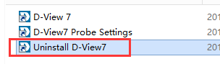

#### **Step 2:** Retain the MongoDB when uninstalling

You need to uninstall the current version of D-View 7. During the uninstall process, you will get an alert, and ask "Do you want to uninstall as well MongoDB?", choose "No(N)". After that, this server will be used as a database Server.

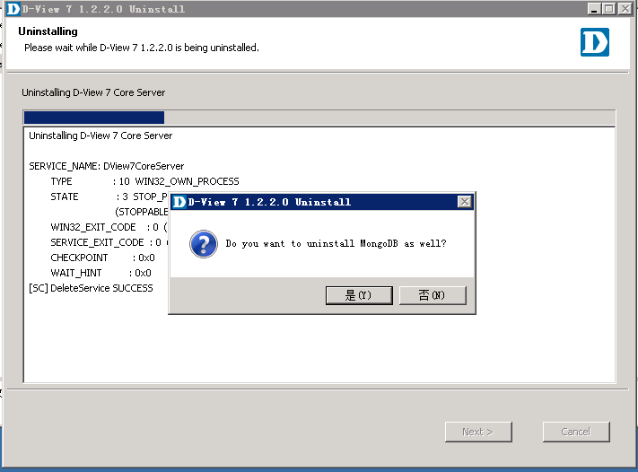

### Windows NLB Server

Generally, you make the best performance server as the master server (which server the priority is 1), the master server will install 4 services: D-View 7 Core Server, D-View 7 LicenseAgent server, D-View 7 Probe server, D-View 7 probe file server. The other slave servers only install D-View 7 Core Server.

OS needed：Windows server 2008 R2 or winserver2012

Service needed：Network Load Balancing(NLB)

Topological structure:

Cluster IP:192.168.0.100

User

Node 2

192.168.0.2

Node 1

192.168.0.1

1. First, you need at least two servers which installed winserver2008 R2 or winserver2012.
2. Then, config your node server IP in the same net segment and install the system comes with service “NLB” respectively.
3. Open the Network Load Balancing Manager on the node 1 server，According to the configuration shown as below.
4. Right Click “Network Load Balancing Cluster”, then click “New Cluster”.

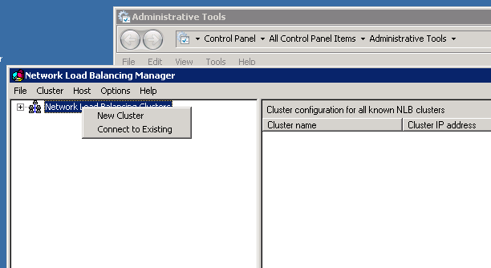

1. Input the node 1 server IP, click Connect.

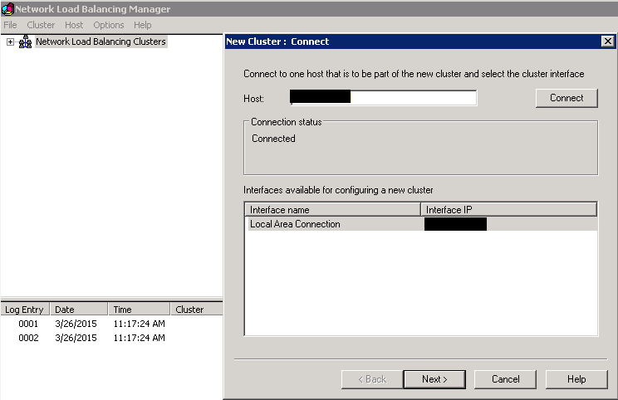

1. When the status is connected, click “Next”, set Host Parameters. The Priority is different among the node servers, in a general way, the better the performance, the lower the Priority and the lowest Priority is first to be used.

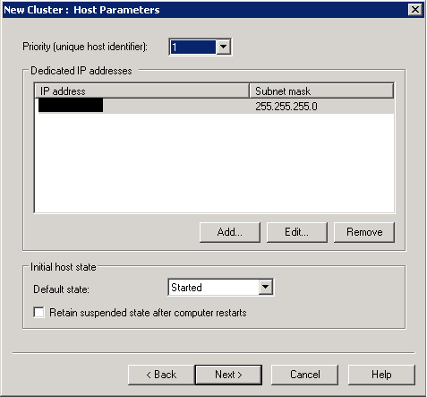

1. Click “Next”, set Cluster IP Addresses.

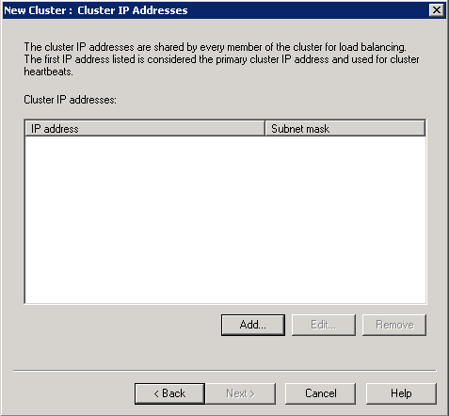

1. Add Cluster IP Address.

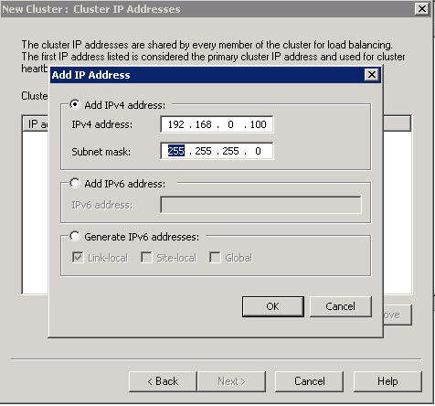

1. Then set the cluster Parameters，Full Internet name is domain name which has been registered and binding the cluster IP. AS the node server is Single NIC, select “Multicast” mode.

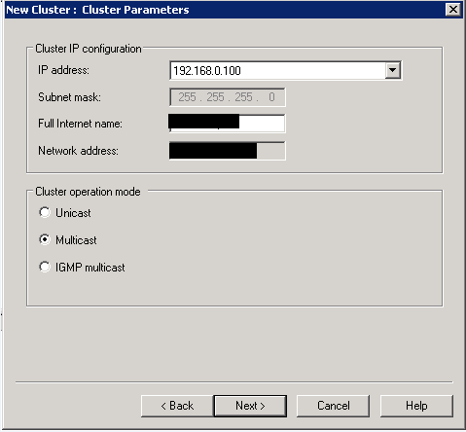

1. Next, Config Port Rules.

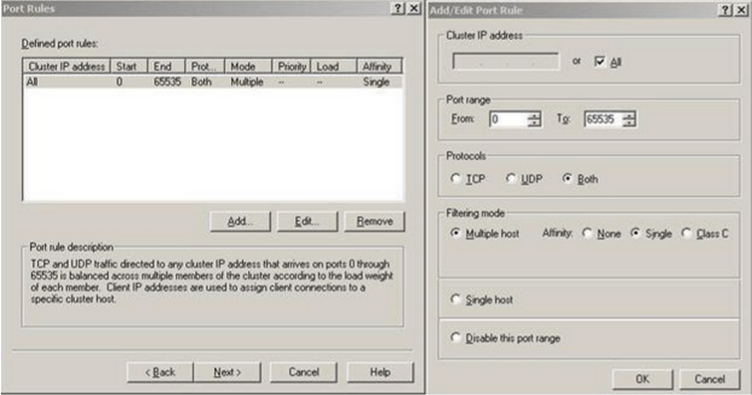

1. Click Finish to complete the node 1 server configuration, waiting for the status changes to converged, Click the Cluster and Select “Add Host To Cluster”.

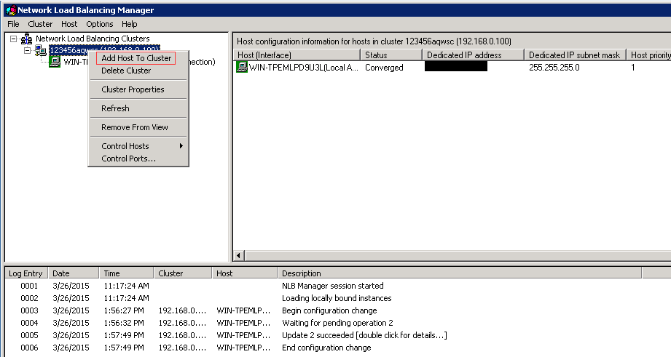

1. Input the node 2 server IP in the box, After the connection, following the prompts to set node 2 server(similar to node 1 server).

Open Network Load Balancing Manager on node 2 server, select “connect to Existing”.

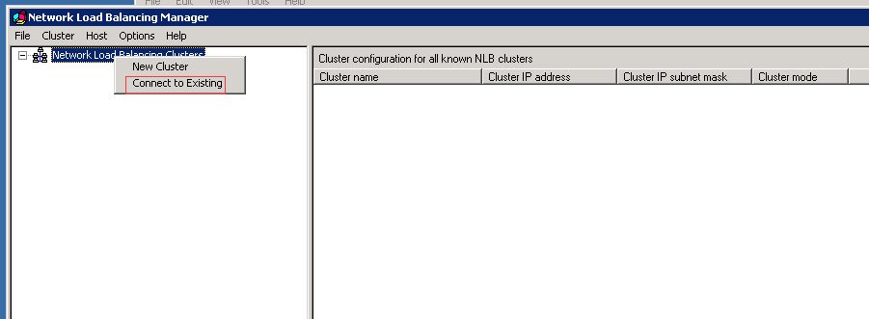

1. Input the node 1 server IP, click “Connect”，when the status changes to Connected, then Finish.

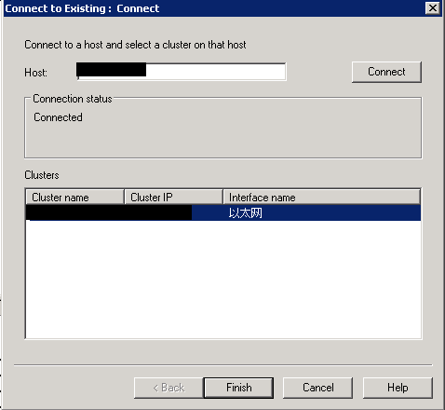

1. Here to, the NLB Cluster configuration of two servers is ok. Other node configuration is the same, you can access the content of the two node servers through Cluster IP.

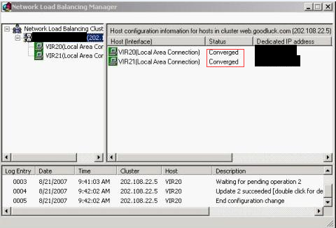

### Install D-View 7

Next, install D-View 7 server.

#### Master Server

##### Step 1: Run installation

Double click the D-View 7 installation package on the master server.

##### Step 2: Server Type select

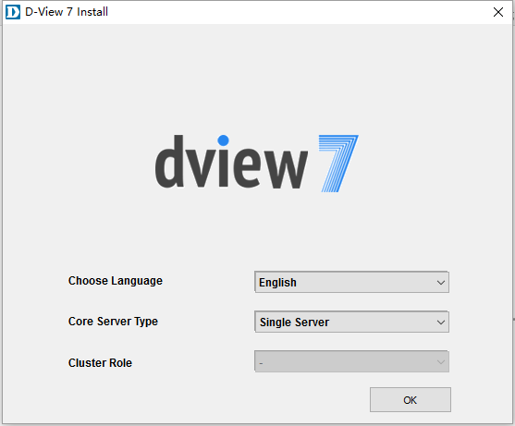

Core Server Type: select “Cluster Server”, Cluster Role select “Master”.

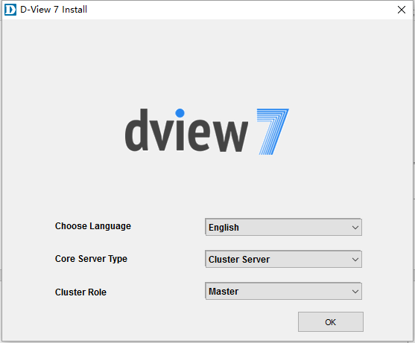

Click “OK” button.

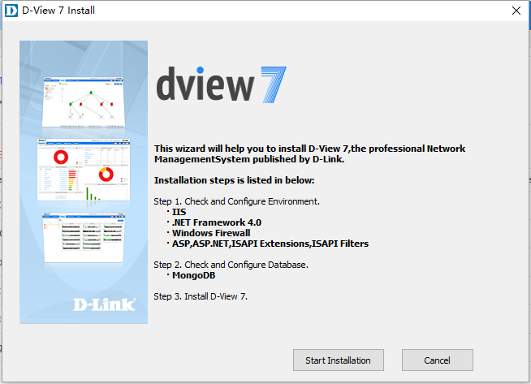

##### Step 3: Check and Configure Environment

Click “Start Installation” button.

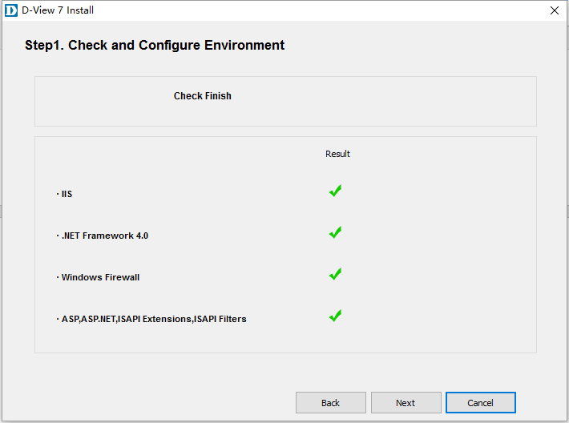

##### Step 4: Check and Configure Database

Click “Next” button.

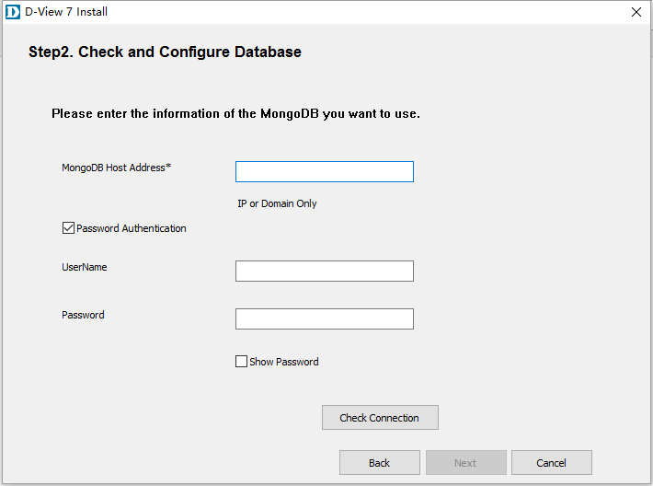

First, you need to add Inbound Rules for the MongoDB communication port on the database server's Windows firewall (default port: 27017).

Input the database server IP.

* If the original MongoDB was installed by the”MongoDB Tool”, you can just un-check the “Password Authentication”.
* If the original MongoDB was installed by DV7 installation, the “UserName” should input “admin” & the “Password” should input “admin”.
* If the original MongoDB was installed and registered by yourself. Please input the username and password which you set.

If the MongoDB need Password Authentication, you can check the radio button then input the UserName and Password; Otherwise don’t check box, click “Check Connection” button.

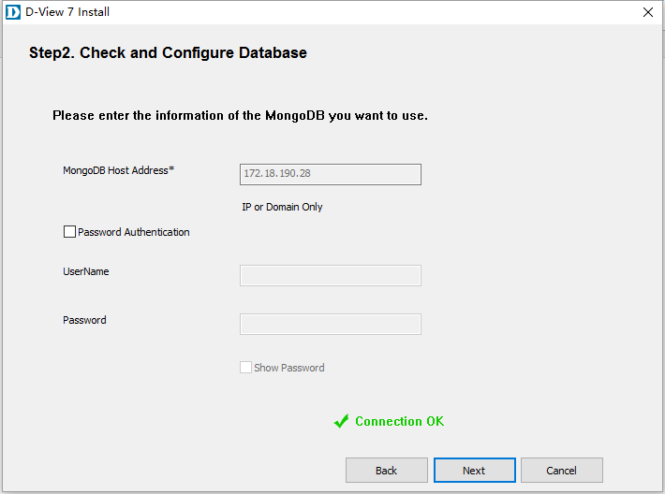

##### Step 5: Install D-View 7

When Check Connection shows "Connection OK", click “Next” button. You can see the following window:

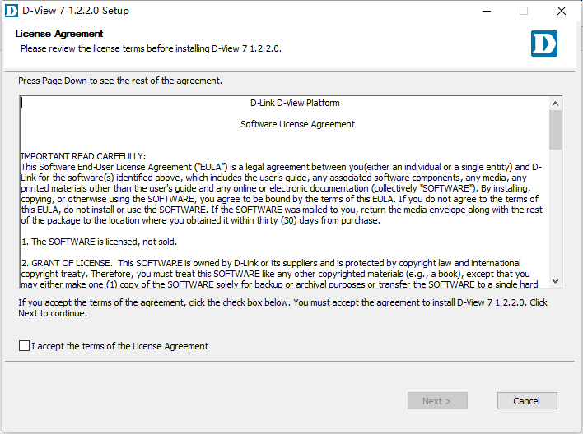

Check “I accept the terms of the license Agreement” box and click “Next” button.

##### Step 6: D-View 7 Web url & probe settings

Input the cluster IP in the textbox, Local Probe IP Address select local server IP then click “Next” button.

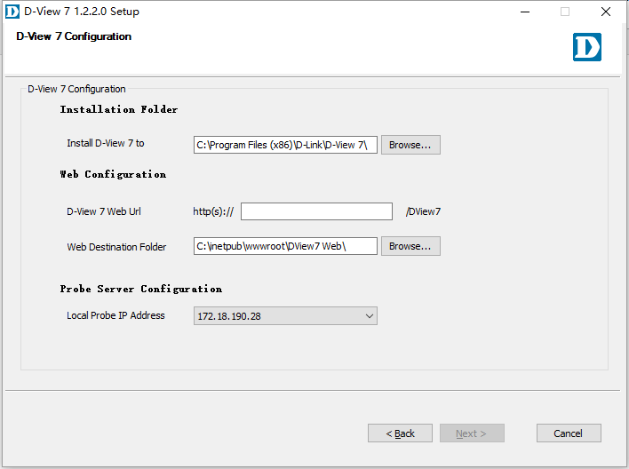

##### Step 7: Click “Install” button

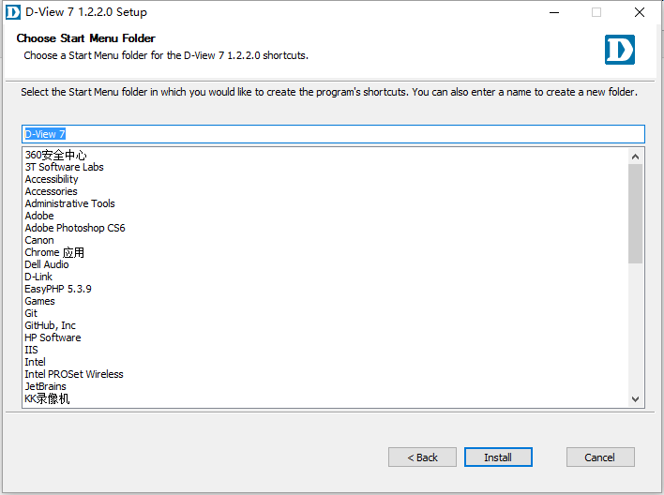

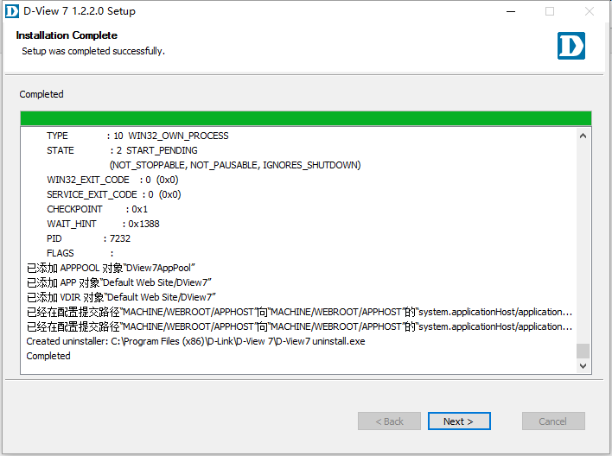

After done, click “Next” button.

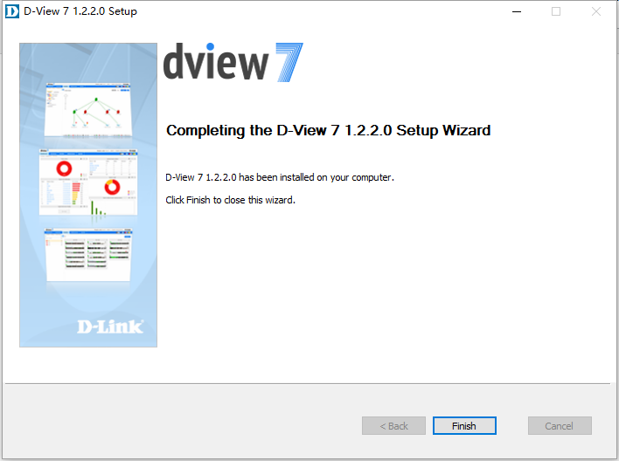

Click “Finish” button, the master server is ok.

#### Slave Server

Then install the slave server, similar to the master server.

##### Step 1: Run installation

Double click the D-View 7 installation package on the slave server.

##### Step 2: Server Type select

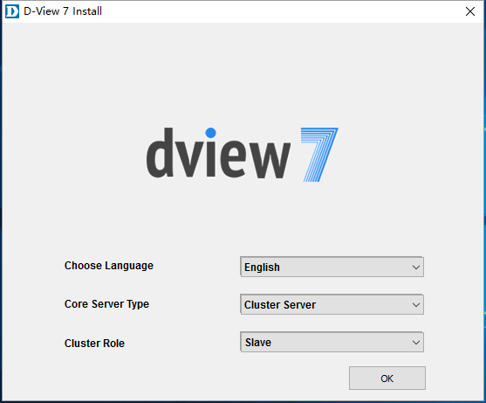

Core Server Type select “Cluster Server”, Cluster Role select “Slave”, click “OK” button.

##### Step 3: Check and Configure Environment

Click “Start Installation” button.

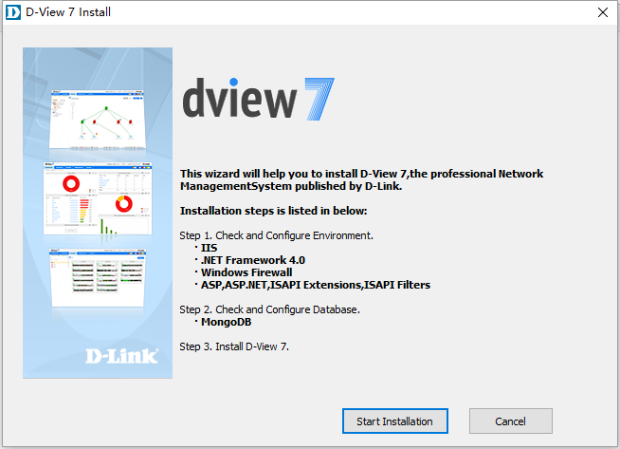

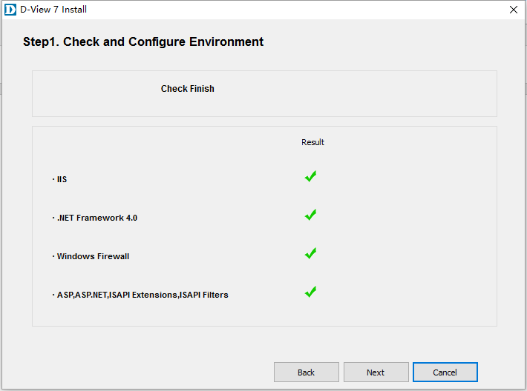

##### Step 4: Check and Configure Database

Click “Next” button.



##### Step 5: Install D-View 7

Input the database server IP (MongoDB server), the “UserName” should input “admin” & the “Password” should input “admin”. click “Check Connection” button, when Check Connection shows "Connection OK", click “Next” button.

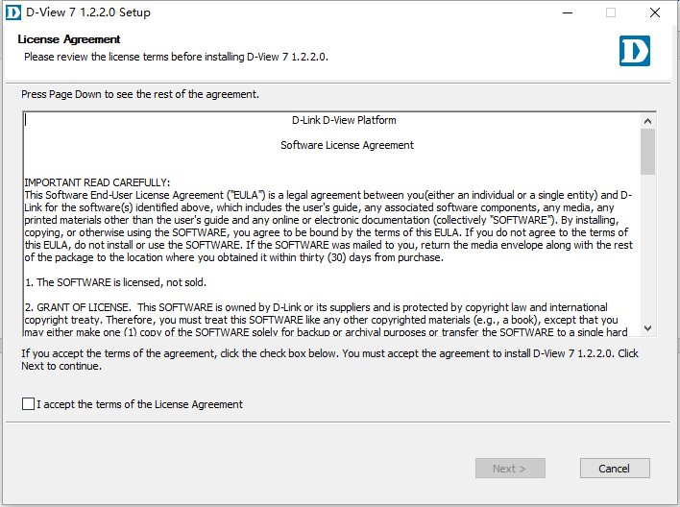

Check “I accept the terms of the license agreement” box and click “Next” button.

##### Step 6: D-View 7 Web url & probe settings

Input the cluster IP in the “D-View 7 Web Url” then click “Next” button.

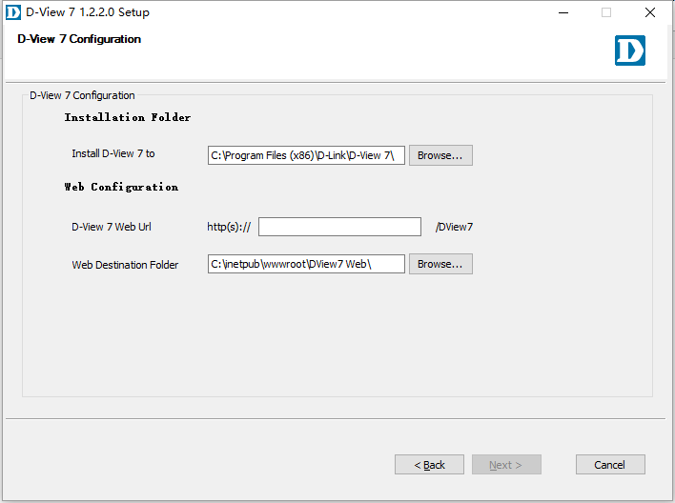

##### Step 7: Click “Install” button

Click “Install” button, according to the prompt operation until completed.

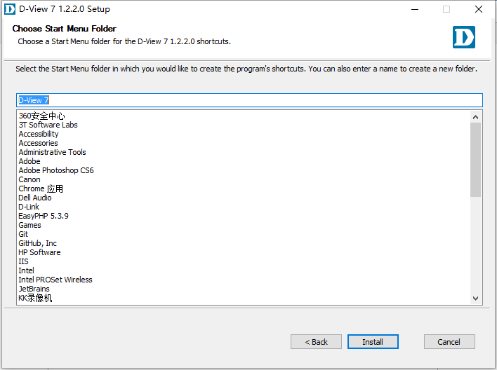



If you have multiple slave servers, only need to repeat the above operation. When all the installation is completed, you can access D-View 7 by entering “cluster IP/DView7” in the browser or through a shortcut to the desktop.

### Remove the original Core Server IP from the Database Server

When you login D-View 7 Cluster, you'll find an extra IP in the “System>About>Core Server IP”, which is the original D-View 7 Server IP. You can do the following steps on the database server to remove it:

1. Run Windows cmd as administrator.
2. Use “cd” command to change the path to MongoDB installed path.

e.g.: “cd C:\Program Files\MongoDB\bin”



1. Input “mongo.exe” and press “Enter” to try to connect Database, please make sure the MongoDB service was started.

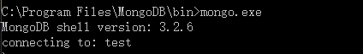

1. After login success, input “use admin” to switch the admin database.



1. Input “show users” and try to check the current database’s all users, check whether MongoDB was used authentication mode.

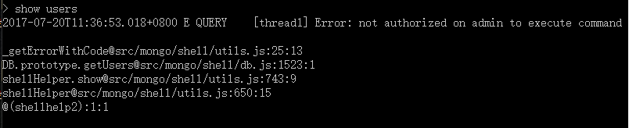

1. If cmd didn’t print any error message, then go to Step 10.
2. If cmd print authenticate failed message, then user need to user database account & password to login. The error message is: Error: not authorized on admin to execute command…
3. Input “db.auth(‘admin’,’admin’)” and press Enter to login admin database.



1. If cmd print 1 that means login success, otherwise, go to step 8 to try again.
2. Input “use DView7” to switch D-View 7 database.



1. Run another Windows cmd, use “ipconfig -all” command to query the MongoDB server’s IP and MAC.
2. 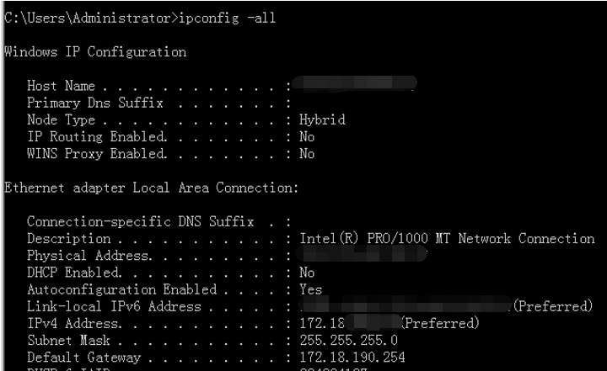
3. Input ”db.Cor_ClusterInfo.remove({CoreMAC:’AA:BB:CC:DD:EE:FF’})”, the configuration is complete.( ‘AA:BB:CC:DD:EE:FF’ is copied from D-View 7>System>About>Core Server IP, according to the query results of step 11.)

